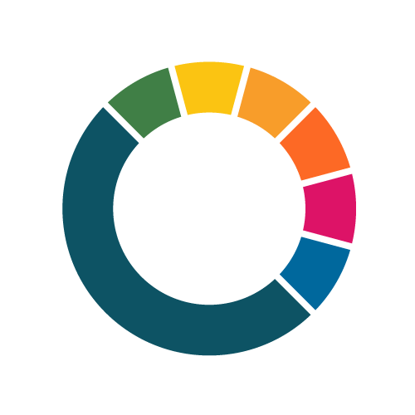
Climate City Contract

2030 Climate Neutrality Commitments

Climate Neutrality Commitments of the City X

Add your city logo here

Disclaimer
The content of this document reflects only the author’s view. The European Commission is not responsible for any use that may be made of the information it contains.
Table of contents
1 Introduction 1
2 Goal: Climate neutrality by 2030 1
3 Key priorities and strategic interventions 1
4 Principles and process 1
5 Signatories 2
6 Contract with signatures 3
Appendix: Individual Signatory Commitments 4

Introduction
Explain your city’s motivation to join the EU Mission “100 climate-neutral and smart cities by 2030” and highlight your city’s present commitments to climate action. You may also want to include the aims of this document.
Your text
…

Goal: Climate neutrality by 2030
Articulate your 2030 climate neutrality ambition, as expressed and defined in your Cities Mission Expression of Interest (EoI). This should include your ambition and commitment to a 2030 horizon as a whole city, as well as describe any exclusion areas and summarise how these areas would be addressed beyond 2030. (A more detailed plan for exclusion areas should be included in the 2030 Climate Neutrality Action Plan.) Your 2030 ambition should be supported at a minimum by a Council decision, and it is recommended that it is also supported by a wider stakeholder group. We also recommend you to list other co-benefits you aim to achieve when working towards the climate neutrality goal, like well-being, health, equity, justice, financial savings.
Your text
…

Key priorities and strategic interventions
This is the core section of the Commitments document that should summarise at least 3 or 4 systemic strategic priorities that need to be implemented for your city to become climate neutral by 2030. These should be meaningful changes that will have a profound impact on reducing GHG emissions in your city, like decarbonising the heating system in the city or generating 100% energy from renewables. The individual commitments between your city and other stakeholders should address these key priorities and contribute to reaching them. The annexed 2030 Climate Neutrality Action Plan should describe the all interventions, including those to reach your priorities as well as all further actions, in detail and describe how your city plans to implement them.
Your text
…

Principles and process
Highlight the key principles that will guide your city as it implements its Climate City Contract, like accountability, transparency, or an open attitude to new approaches. The process should encompass principles like co-creation, innovation, multi-actor and citizen engagement, and should be systemic and demand-driven in nature. It should also be based on monitoring and joint learning. The Commitments Guidance document provides more specific guidance on how integrate these principles into your own process.
Your text
…

Signatories
Include a list of stakeholders who have committed to help your city achieve its goal to reach climate neutrality by 2030. Detailed commitments and agreements between individuals or groups of stakeholders should be appended to this Commitments document. This list will likely increase over time.
Name of the institution | Sector/Area | Legal form | Name of the responsible person | Position of the responsible person

Contract with signatures
Express joint commitment / agreement for all stakeholders who sign this 2030 Climate Neutrality Commitments document.
Example: We, the undersigned, hereby commit to help make the City X climate neutral by 2030. We agree on the joint ambition and commitments, as formulated in the City X’s Climate City Contract.

Date of signature Name Signature

___________________________________________________________
Mayor of City X

_____________________________________________________________
President, City X Development Agency

_______________________________________________________
Provost, University of City X

_______________________________________________________
CEO, Utility X

Appendix: Individual Signatory Commitments
Specific agreements that articulate the details of the climate action(s) between the municipality and other stakeholders (individual or groups) can be added to the Commitments document appendix.

